Plan for the future.

Protect them today.

Dear Michele,

If you include Anderson Animal Shelter in your estate plans now through the end of 2020, Anderson will receive $500 to support our life-saving programs and services!

That’s right, your plans for the future will help us protect the lives of animals today! Each new or newly confirmed planned gift will trigger a donation of $500 to Anderson, up to a total of $20,000.

Here’s how it works:

1. Include Anderson Animal Shelter in your will or trust, as a beneficiary of a life insurance policy, retirement
plan or bank account.

2. Tell us about your gift. Complete and return the enclosed Intention Form or visit us online at
andersonanimalshelter.org/donate to complete the online form.

3. A generous donor will contribute $500 to Anderson, while funds last!

If you have already named Anderson as a beneficiary of your estate but haven’t yet confirmed your commitment with us, you can trigger a $500 donation to Anderson just by filling out and returning the Form in the mail or online!

We would like to express our deepest appreciation to donors Bob Ross and Steve and Mary Hinze for providing us with this Legacy Fund Challenge opportunity which will help transform our future and provide immediate support during these difficult times.

If you are ready to participate in Anderson’s Legacy Challenge, you can create a free, legally valid will online in less than 20 minutes! You can get started by visiting FreeWill.com/AndersonAnimalShelter.

The process is simple. Your commitment is one of love for your family and the cause you hold dear.

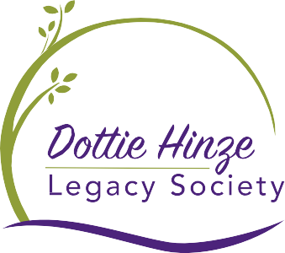
Sincerely,
All donors who have included Anderson in their estate plans are eligible to become members of the Dottie Hinze Legacy Society.

Susan Lyons,
Director of Development
slyons@andersonanimalshelter.org
847.697.2880 x 31

